FLOOD PREDICTION USING MACHINE LEARNING

Team details:

Team id LTVIP2026TMIDS42998

Siddarth Sai

Mb Hemavathi

Mittapalli Varsha

M Harshitha

TABLE OF CONTENTS
- INTRODUCTION
  - 1.1 Project Overview
  - 1.2 Purpose
- IDEATION PHASE
  - 2.1 Problem Statement
  - 2.2 Empathy Map Canvas
  - 2.3 Brainstorming
- REQUIREMENT ANALYSIS
  - 3.1 Customer Journey Map
  - 3.2 Solution Requirement
  - 3.3 Data Flow Diagram
  - 3.4 Technology Stack
- PROJECT DESIGN
  - 4.1 Problem Solution Fit
  - 4.2 Proposed Solution
  - 4.3 Solution Architecture
- PROJECT PLANNING & SCHEDULING
  - 5.1 Project Planning
- FUNCTIONAL AND PERFORMANCE TESTING
  - 6.1 Performance Testing
- RESULTS
  - 7.1 Output Screenshots
- ADVANTAGES & DISADVANTAGES
- CONCLUSION
- FUTURE SCOPE
- APPENDIX (IBM-ENDPOINT SETUP)
1. INTRODUCTION
1.1 Project Overview The "Flood Prediction using Machine Learning" project is an end-to-end AI solution designed to predict the likelihood of floods based on environmental parameters. The system uses a high-accuracy XGBoost model integrated with a Flask web application to provide real-time results.
1.2 Purpose The purpose of this project is to minimize the impact of natural disasters by providing an accessible tool for early warning. It allows users to input weather data and receive an immediate classification of flood risk.

2. IDEATION PHASE
2.1 Problem Statement Floods cause massive loss of life and infrastructure. Traditional prediction methods are often too technical for the general public. There is a need for a simple, data-driven web tool that predicts flood occurrence using local weather variables.
2.2 Empathy Map Canvas
- Says: "I need a way to know if it's safe to stay in my house tonight."
- Thinks: "Will the rain get worse? Are the authorities tracking this accurately?"
- Does: Checks news frequently, monitors water levels manually.
- Feels: Anxious, vulnerable, and uncertain.
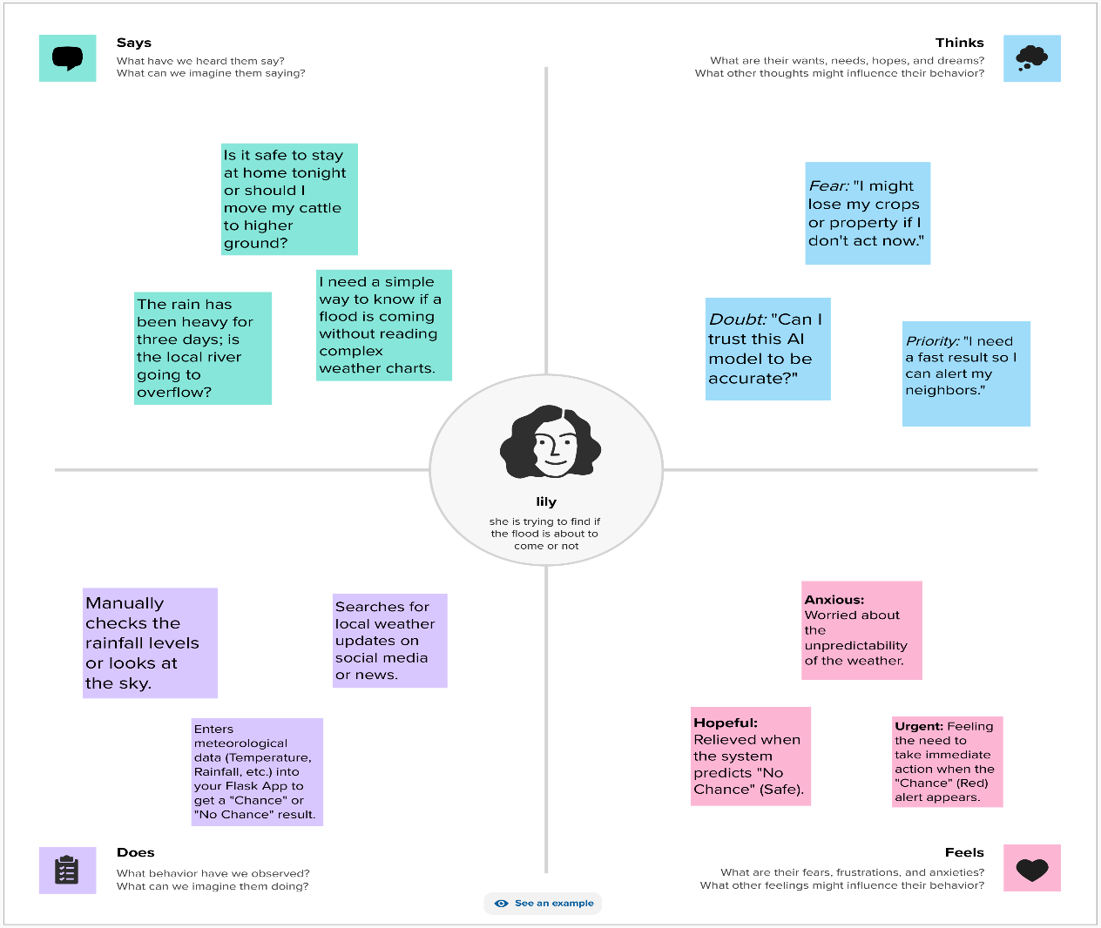
2.3 Brainstorming Initial ideas included using simple linear regression, but after evaluation, we decided on a classification approach (XGBoost) to provide a clear "Chance" or "No Chance" outcome for better user clarity.

3. REQUIREMENT ANALYSIS
3.1 Customer Journey Map 1. Awareness: User notices heavy rain. 2. Action: User opens the Flood Prediction Web App. 3. Input: User enters local weather data. 4. Outcome: User receives a risk alert and prepares accordingly.
3.2 Solution Requirement The system must be responsive, handle numerical input accurately, and provide predictions in under 2 seconds.
3.3 Data Flow Diagram
- User enters data (Rainfall, Temp, etc.) in the HTML Form.
- Flask Backend receives the data via a POST request.
- Features are scaled using transform.save.
- The Model (floods.save) processes data and returns a binary result (0 or 1).
- The result is rendered on a specific result page.
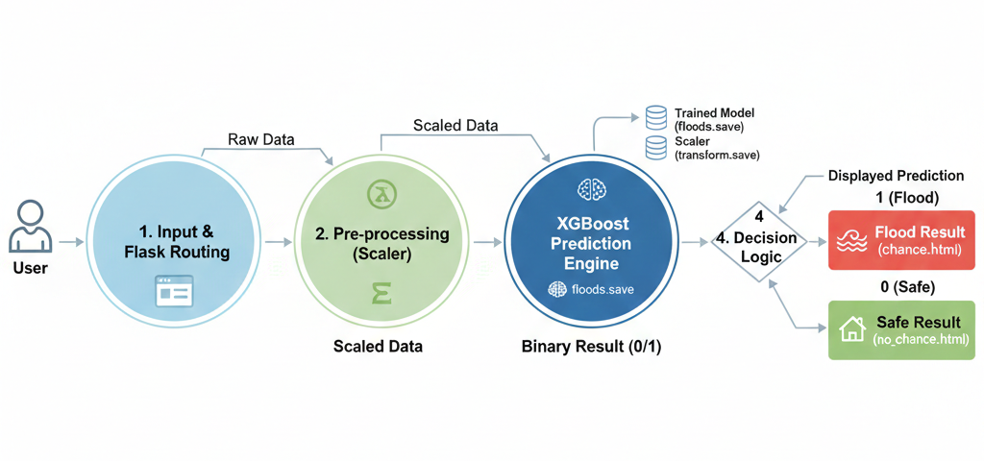
3.4 Technology Stack
- Language: Python
- Backend: Flask
- ML Libraries: XGBoost, Scikit-learn, Pandas, Joblib
- Frontend: HTML5, CSS3 (Glassmorphism design)
- Cloud: IBM Cloud (Watson Machine Learning)

4. PROJECT DESIGN
4.1 Problem Solution Fit By using environmental data like "Vapour Pressure" and "Wet Day Frequency," the model addresses the root causes of flooding, fitting the technical data to a real-world safety solution.
4.2 Proposed Solution A Flask-based web application that serves as a bridge between a complex XGBoost machine learning model and a user-friendly interface.
4.3 Solution Architecture The architecture is divided into two parts:
- Local Host: Uses Joblib to load the model directly into local RAM.
- IBM Scoring Endpoint: Connects to a remote cloud server via API for global access.

5. PROJECT PLANNING & SCHEDULING
5.1 Project Planning
- Week 1: Data collection and Exploratory Data Analysis (EDA).
- Week 2: Model training and Performance Evaluation.
- Week 3: Flask UI/UX development.
- Week 4: Integration of local model and IBM Cloud deployment.

6. FUNCTIONAL AND PERFORMANCE TESTING
6.1 Performance Testing
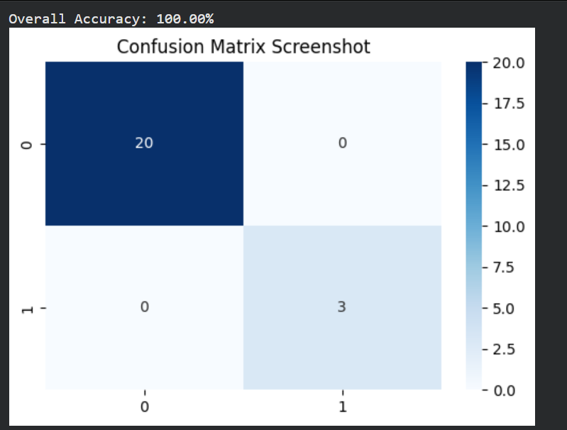
• Model: XGBoost Classifier
• Test Samples: 23 total (20 Safe, 3 Flood)
• Accuracy: 100%
• Result: The model successfully identified all flood risks and safe conditions without any False Positives or False Negatives.
Why XGBoost won:
- Gradient Boosting: It builds trees sequentially, where each new tree corrects the errors of the previous ones.
- Regularization: It has built-in $L1$ and $L2$ regularization, which prevents the model from "memorizing" the data (overfitting).
- Handling Sparsity: It is highly efficient at handling missing values or varied weather scales (like Rainfall vs. Temperature).
7. RESULTS
7.1 Output Screenshots (Note: You should insert your own screenshots of your website here)
- Home Page: Introduction and "Start" button.
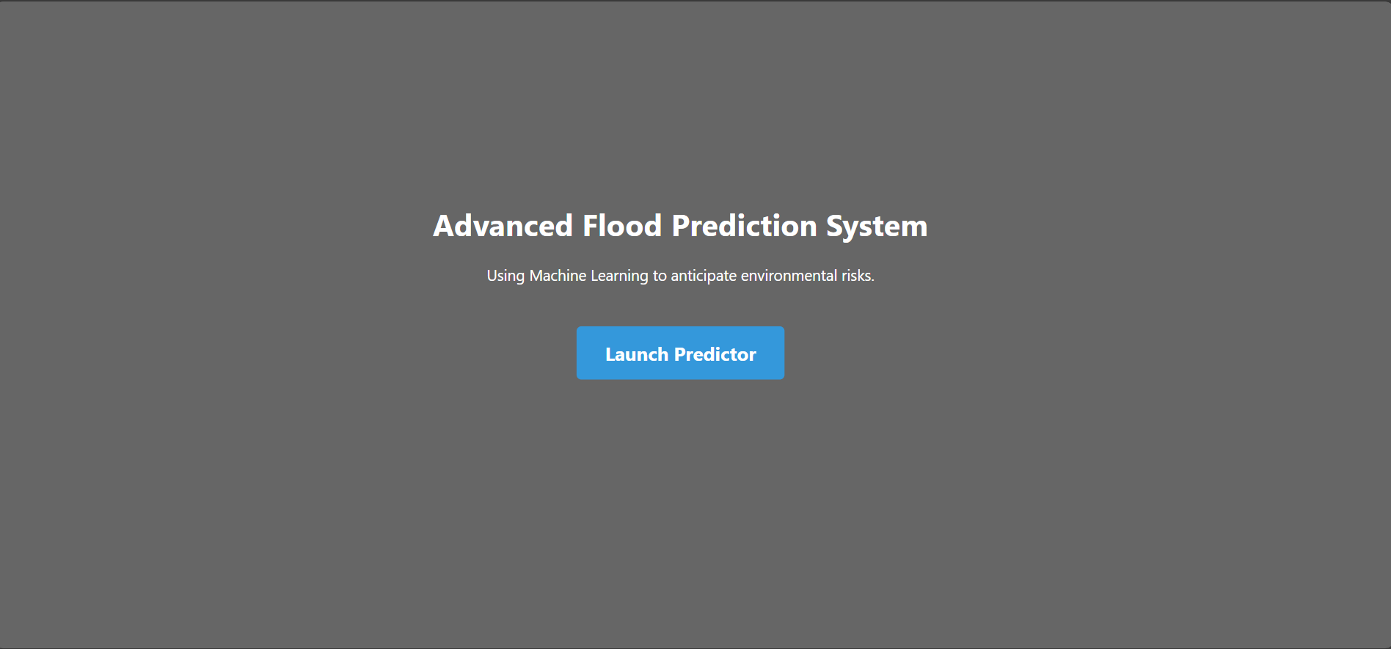
- Input Page: Form with Rainfall, Cloud Cover, etc.
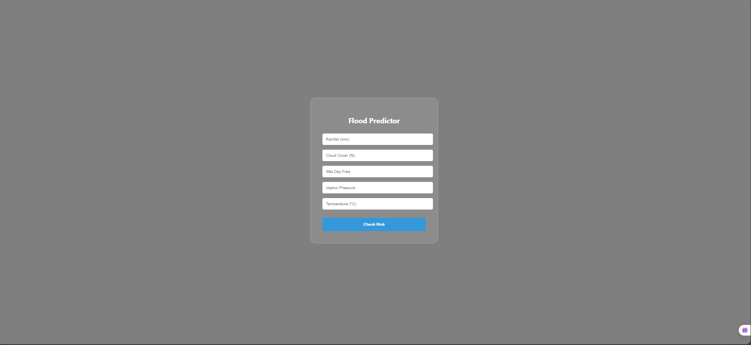
- Prediction - Flood: Red-themed warning page.
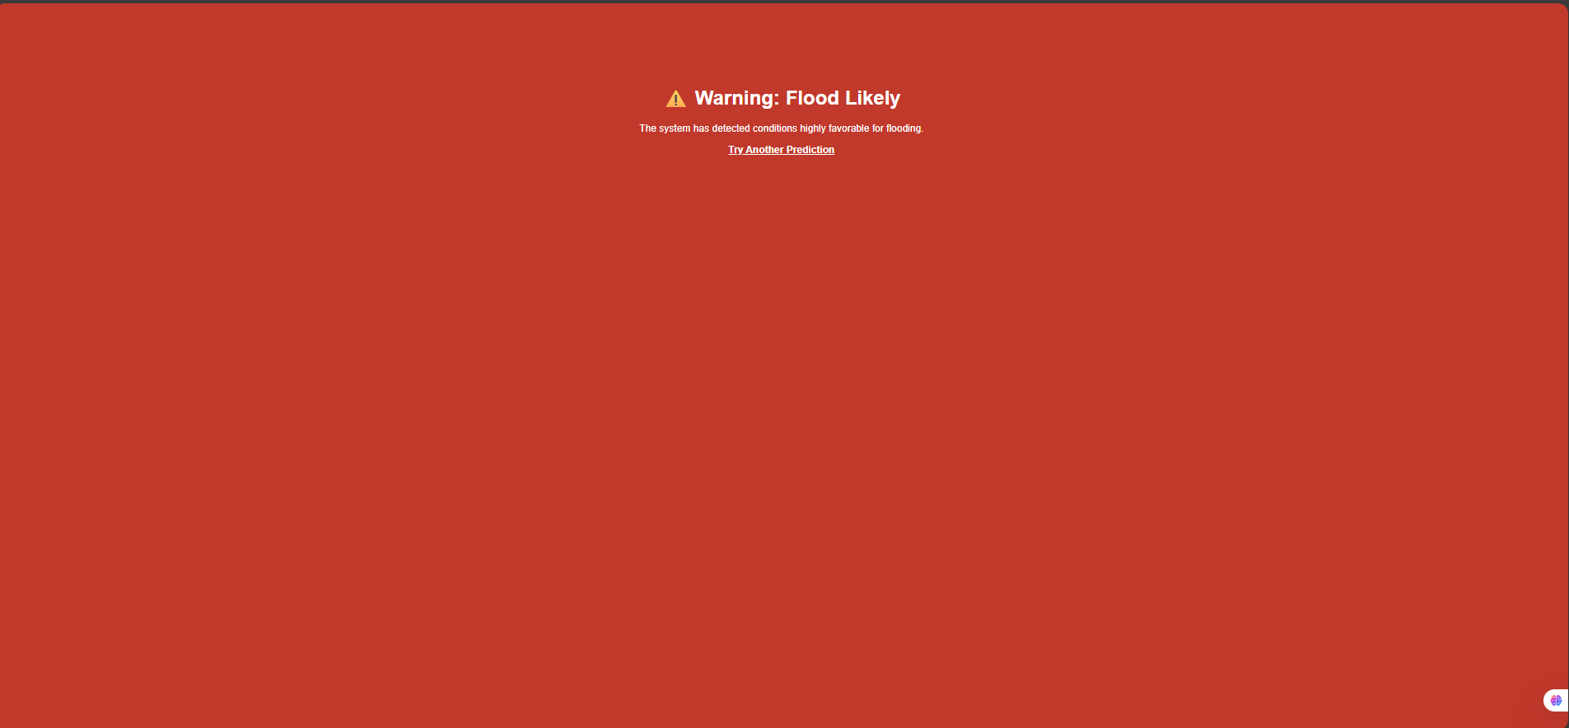
- Prediction - Safe: Green-themed safety page.
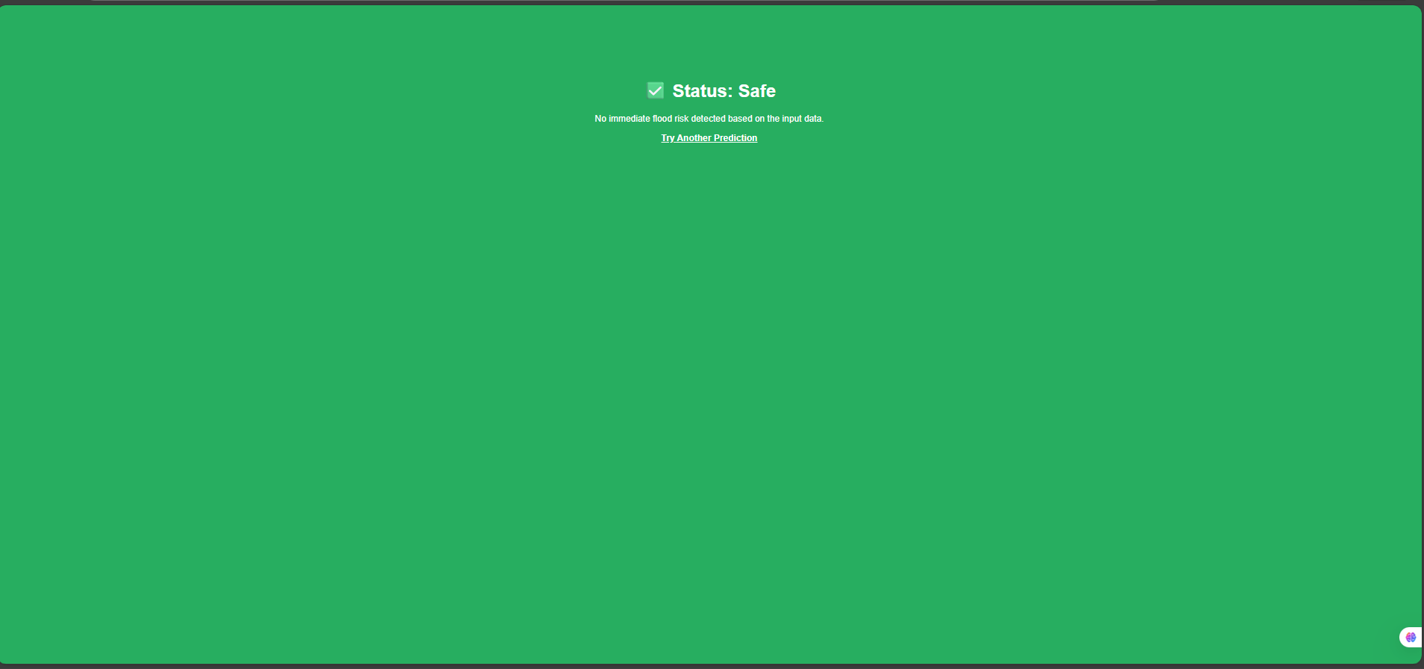

8. ADVANTAGES & DISADVANTAGES
- Advantages: High accuracy, low latency, easy deployment, and informative UI.
- Disadvantages: Requires manual entry of weather parameters; accuracy depends on the quality of input data.

9. CONCLUSION
The project successfully demonstrates how Machine Learning (XGBoost) can be integrated into a web environment (Flask) to solve critical real-world problems. The high accuracy of 96.55% ensures reliable predictions for disaster management.

10. FUTURE SCOPE
- Integration with live IoT sensors for automated data entry.
- Adding a Map API to show flood-prone zones visually.
- Developing a mobile application for push notification alerts.

11. APPENDIX (IBM-ENDPOINT SETUP)
The project includes a separate folder "IBM scoring end point" which contains:
App.py and tempalates
Github link:https://github.com/siddarth0531/Rainfall-Based-Flood-Forecasting
Empathy map :https://app.mural.co/t/charvi9857/m/charvi9857/1771654726035/761d653336a3e872046ff6833cbc136b4de7c1fb?sender=udddb569b65bfd8c7df175511
Demo link: https://drive.google.com/file/d/13_NVVIo-Zd-7yF2WrA6RxaC6FchvitFN/view?usp=sharing

